How to use MN Traffic Generator

# Introduction

[MinnesotaTG](http://siwa-umh.cs.umn.edu/) is a project developed at the [University of Minnesota](http://www1.umn.edu/twincities/index.html). MinnesotaTG is built based on two existing traffic generators: (1) [BerlinMod](http://dna.fernuni-hagen.de/secondo/BerlinMOD/BerlinMOD.html" \t "_blank)and (2)[Thomas-Brinkhoff](http://iapg.jade-hs.de/personen/brinkhoff/generator/" \t "_blank). The purpose of MinnesotaTG is to take an arbitrary region in the United States and generate traffic data from that region. Without this tool, generating this traffic is a complicated and drawn out process because of the number of configuration steps necessary to get either Thomas-Brinkhoff or BerlinMod both up and running, and able to work on a user specified region. The generation of the traffic is not done by the tool itself, but rather it is performed by these two different traffic generators.

# Instructions

## Step 1. Select Target Area for Traffic Generation

First you can navigate the map on the website to any location **within US** or using the search box to find it.

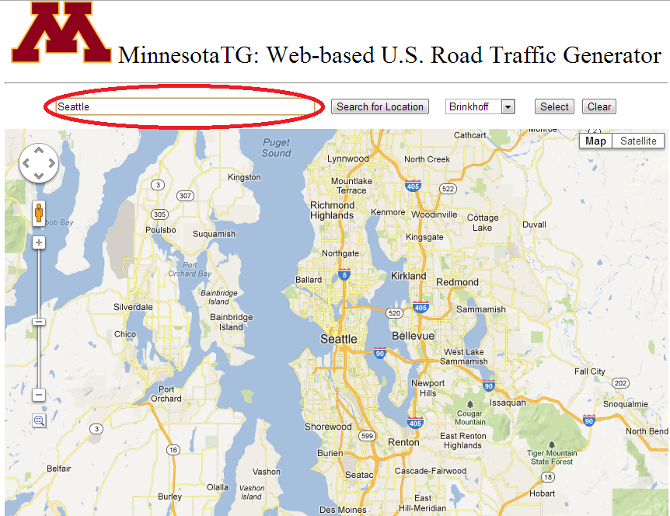

After that, left click the mouse over the map, where a marker will be placed over the map. The red rectangle that bounded by the two markers is the area we will generate the traffic for you.

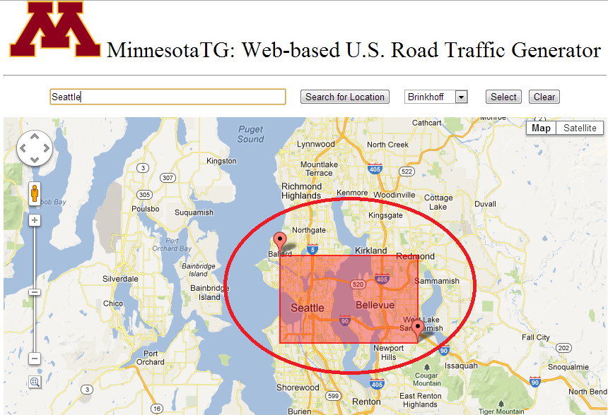

## Step 2. Select Traffic Generation Model

Use the dropdown box to select the traffic generation model. In our system we support (1) [BerlinMod](http://dna.fernuni-hagen.de/secondo/BerlinMOD/BerlinMOD.html" \t "_blank)and (2)[Thomas-Brinkhoff](http://iapg.jade-hs.de/personen/brinkhoff/generator/)

